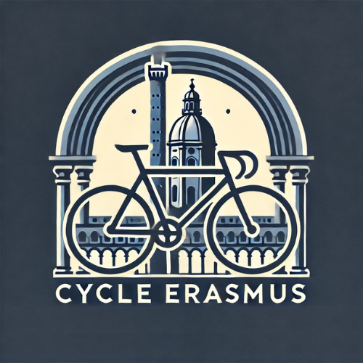
SUBJECT:
Bike Sale: [Your Name] – €[Your Asking Price]

BODY:
Hello Cycle Erasmus Team,
I would like to offer my bike for sale. Below are the details of the bike:
Date of Inspection: [Preferred date for inspection]
WhatsApp Number: [Your WhatsApp Number]
Please find the condition of my bike below, based on the evaluation table:
Bike Element | Good | Okay | Bad
Tires | No visible damage, fully inflated | Minor wear, still functional | Worn out, punctured, or flat
Rust | No rust or minimal | Some rust spots, not affecting function | Significant rust affecting structure
Brakes | Fully functional, smooth operation | Minor issues, slight adjustments needed | Major issues with braking power or responsiveness
Rims | No cracks or damage, straight | Minor scratches, slight bending | Cracks, bent rims, significant damage
Saddle | Comfortable, no tears | Some wear, still usable | Torn, uncomfortable, or damaged
Pedals | Fully functional, no damage | Minor wear or small issues | Significant damage or non-functional
Transmission System | Smooth, all gears working | Some minor skipping or difficulty | Major shifting issues, dysfunctional
Handlebars | In good condition, no cracks | Slight wear or minor bend | Major damage or bent
Chain | New or in excellent condition | Slight wear but still functional | Worn out or damaged, may need replacement

Please send the following pictures via the attachments section
- Two overall pictures of the bike (front and side views)
- Close-up pictures of the rims, transmission system, chain, pedals, tires, and handlebars

Additional Comments:
Please include any additional information or comments, such as recent maintenance, any replaced parts (e.g., new tire, chain, brake pads, etc.), or any other details that may help us assess your bike.

A Special Touch for Your Bike:
When we purchase your bike, we’ll give it a name based on your personal experience with it! This is our way of immortalizing your Erasmus journey. For example, if you were famous for drinking through your Erasmus, it could be 'Ares' Drunk Carrier'! It’s a fun way to keep the memories alive!

Your Erasmus Journey in a Few Words:
We’d love to hear about your unique Erasmus experience in a few words! Share what made your journey special, funny, or memorable. We’ll use this to inspire the name we give to your bike!

Looking forward to hearing from you!
Best regards,
[Your Name]

